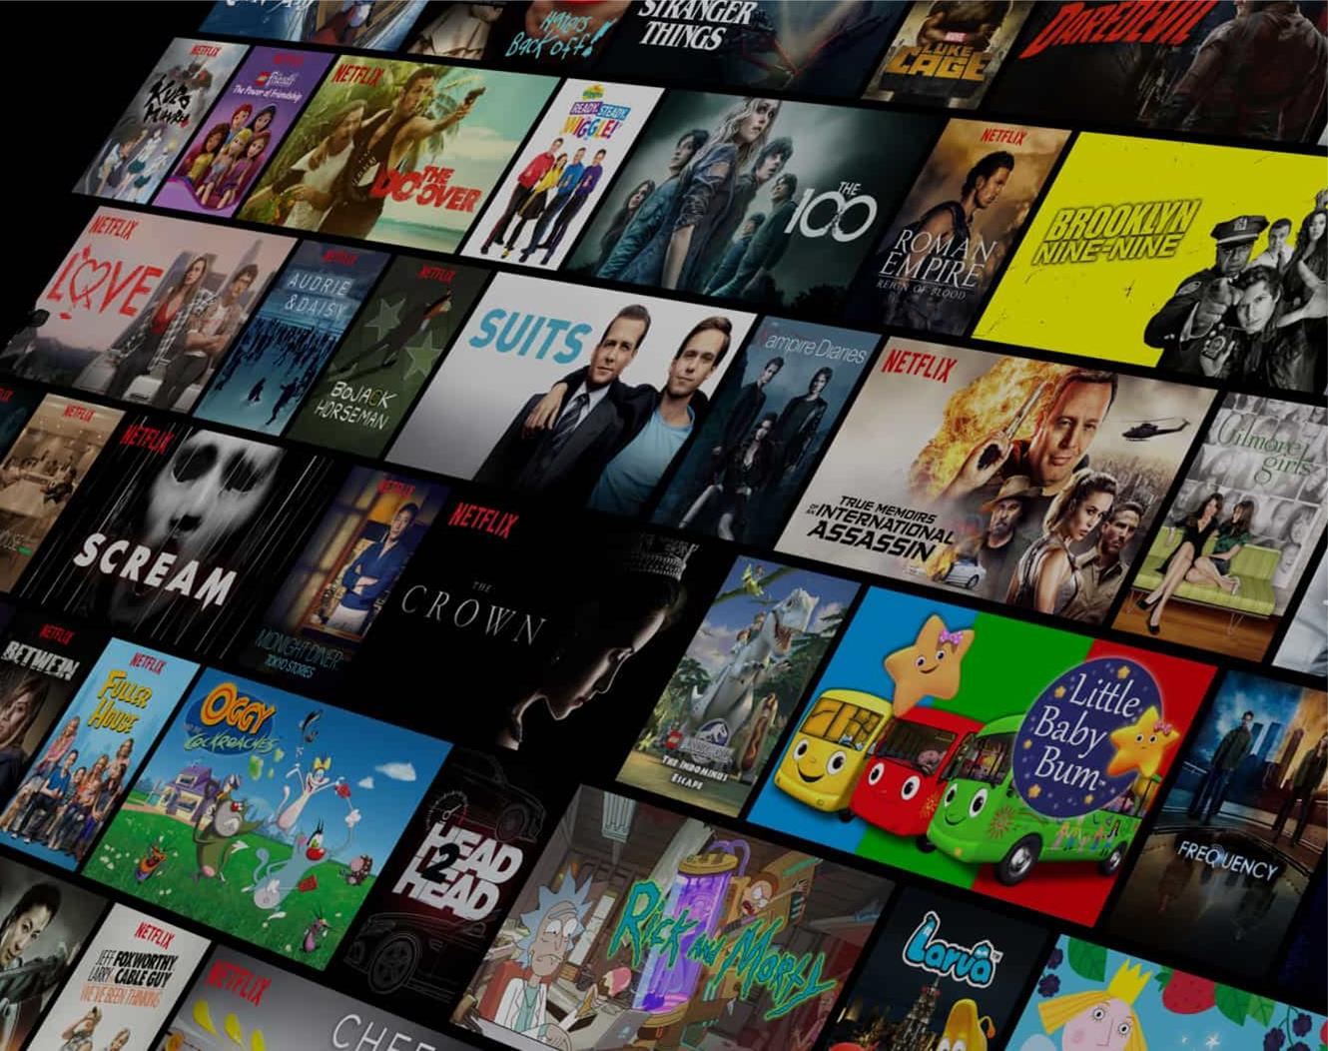

Data Science For Better User Experience: A Netflix Case Study

Shanistha Jagannath Shetty

# INTRODUCTION TO NETFLIX

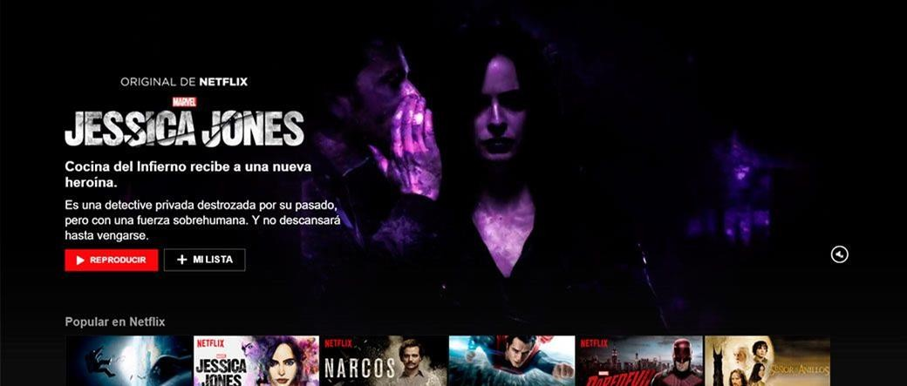

**Netflix is a streaming service that offers a wide variety of TV shows, movies, documentaries, and more on thousands of internet- connected devices. It was founded in 1997 and has grown to become one of the largest entertainment platforms in the world.**

# The Role of Data Science

## Analyzing User Data

Netflix's user experience benefits greatly from data science. It involves analysing vast amounts of data in order to gain insights and make data-driven decisions.

## Understanding User Preferences

Netflix's data scientists use complex algorithms and machine learning techniques to analyze consumer preferences and behavior.

## Personalization

Netflix uses data science to personalize the user experience by recommending appropriate content based on individual tastes.

## Improving Content Discovery

Data science helps Netflix improve content discovery by recommending movies and TV series that consumers are likely to like.

Leveraging Data Science



**Personalized Recommendations Curated Content**

**Improved Search and Discovery Enhanced Streaming Quality**

|  |  |  |
| --- | --- | --- |
| **User Data** | **Data Science Techniques** | **Benefits** |
| Viewing History | Collaborative Filtering | Suggests content based on similar viewing patterns of other users |
| Ratings | Content-based Filtering | Recommends content based on user's explicit ratings and preferences |
| Preferences | Machine Learning Algorithms | Learns user preferences over time to provide more accurate recommendations |

# Personalized Recommendations

Enhancing Streaming Quality



**Network Conditions**

* Netflix utilizes data science to analyse

network conditions in real time.

* This enables them to modify streaming parameters to optimize video quality based on available bandwidth.

**User Feedback**

* Netflix collects customer comments to better understand streaming quality concerns.
* Data science approaches are used to identify patterns to improve the streaming experience.

# Content Curation



**Data Science and Content Curation**

Data science is critical to Netflix's capacity to curate content based on user preferences and behaviours.

**Analysing Viewing Patterns**

By evaluating viewing trends, Netflix may learn about the types of material that specific viewers enjoy and are likely to engage with.

**Feedback and Recommendations**

Netflix also takes into account user feedback, such as ratings and reviews, when making personalized suggestions.



# Improving Search and Discovery

### Netflix uses data science to enhance search and discovery features

* By analysing user search queries and interactions, Netflix can provide more accurate search results
* Helps users discover relevant content based on their preferences and viewing history

# Impact on User Experience

### Personalized Recommendations

* + Data science algorithms analyse user preferences and viewing history to make personalized

recommendations.

* + Users are more likely to find material that they enjoy, resulting in improved engagement and pleasure.

### Curated Content

* + Data-driven content curation offers users a varied and relevant selection of movies and TV series.
  + This helps consumers discover fresh material that is relevant to their interests and choices.

### Improved Search and Discovery

* + Data science techniques improve search results and browsing experiences.
  + Users may simply identify the content they're seeking for and discover new titles that match their

preferences.

### Enhanced Streaming Quality

* + Data analysis improves streaming quality dependent on network conditions and user device capabilities.
  + Users enjoy smoother playback, less buffering, and better video quality.

# In Conclusion

Data science has played an important part in improving the user experience at Netflix. Netflix has used data and advanced algorithms to deliver specific suggestions, curate content, improve search and discovery, and increase streaming quality. Netflix's data-driven solutions have propelled it to the forefront of the entertainment industry.